When grey won’t cut it: why prisons are switching to colour printers

Why do businesses stick with black and white photocopiers and printers?
It’s usually a decision based on frugality.

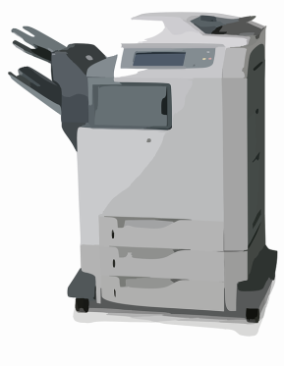

True, colour versions cost a little more than mono versions and need expert servicing plus a higher-quality paper.

But there are always going to be times when you need colour in your lives. Opting for a printer that can multi-task is a far wiser investment.

At the flick of a switch, your day-to-day black-and-white operation mode converts to one which can produce those colour jobs you would otherwise have to head to the printers with. Time and money saved.

We’ve just heard of the most unusual reason ever, though, for an organisation deciding to switch.

Her Majesty’s prisons are having to opt for colour to keep the peace with outraged
inmates.



Clearly, it’s not to create flyers advertising their entertainment programme. Or brochures describing their en-suite accommodation.

The Sun newspaper reports - under the cracking headline COPIERS AND ROBBERS - that, in the midst of the Spice epidemic (we’re not talking drugs, girl-band reunions or the stuff you make mulled wine with), a County Durham prison has had to resort to holding back inmates’ incoming mail. And photocopying every single item.

An onerous chore, even if you employ a Sharp MX-3060 model. But a vital precaution.

Dubious ‘wellwishers’ were dousing their letters and greetings cards with a liberal dose of stupor-inducing liquid Spice. Even children’s drawings and family photos were not sacred.

All prisoners had to do was rip up their letters and photos, smoke them in a roll-up cigarette and get truly stationary.

Prison office photocopiers were drafted in as an emergency measure.
It’s solved the problem, but created a raft of complaints. Firstly, inmates want their mail in its original form. And secondly, the HMP in Durham is lagging (sorry) behind the times and only has mono-copiers.

Jailbirds are seeing red. Even their birthday cards are reduced - or rather enlarged - to a photo-copied, murky grey image on a sheet of A4, which rather ruins the sentiment.

One inmate was so vexed he wrote a letter of complaint to Her Majesty's Prison and Probation Service - and sent a copy to the lags' mag, Inside Time (why didn’t they name it Time In, we wonder?)

We at SoluTech can understand his ire. It’s always the irresponsible actions of the few that spoil it for the many.

But the prison service has been forced to act. Drastic measures had to be put in place to stop Spice-soaked mail getting through.

We have now heard prisons around the UK are buying colour photocopiers so that copies of prisoners’ mail will be of a better quality.

Dare SoluTech, expert suppliers of photocopiers, scanners and printers for offices and businesses in Hull, East Yorkshire and beyond, be so bold as to recommend the Sharp MX-4070 A3 colour device? High performance and high quality colour are guaranteed… And its range of options and upgrades make it adaptable to HMPs’ future needs.

Alternatively, they could cut back on the budget with one of our ‘approved used’ models…

ENDS

